**Company Audit**

**CA. Jomon K George**

**Impacting Factors**

- **Statutory Framework**

**- Professional Pronouncements**

**- Specific Reporting Requirements**

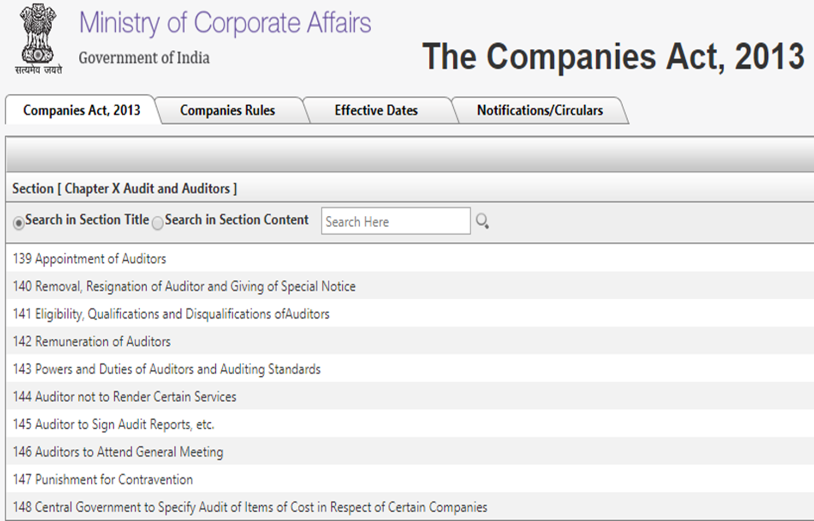



* Cash Flow Statement included in FS.
* Schedule III - The new format (AS & Ind AS)
* Depreciation to be based on Useful lives
* New Format of Auditors Report
* New Reporting Requirements
* CARO 2016
* Fraud Reporting - Penalties for Failure
* Companies AS (Amendment) Rules 2016.
* ICDS … Applicable from FY 16-17
* Ind AS - applicable for certain companies
* Auditing Standards made mandatory

**Are we doing Audits properly ? .. FRRB Findings**

AS Non-Compliance ( 76%)

CA 2013 - Schedule III Non Compliance (18%)

CARO - Non Compliance (6%)

SAs - Scant Regard ….. Very passive

**Cash Flow Statement**

All companies except Small, Dormant & OPCs must prepare Cash Flow Statements

Auditor to report on the CF statements too....

**Depreciation**

Schedule II with detailed list of assets and useful lives.

Residual Value Percentage fixed @ 5%

Component Accounting introduced …

For Intangible Assets, AS 26 to apply…

For Double shift, 50% extra

For Triple shift, 100% extra to be charged

NESD for certain assets …

No 100% depreciation for less than 5000 items

**Accounting Standards**

All ASs (29-2) will continue to apply.

Companies (AS) Rules 2006.

Companies (AS) Amendment Rules 2016.



Changes made by MCA Notification *G.S.R. 364(E) dated 30.03.2016*

The Companies (Accounting Standards) Amendment Rules 2016.

**AS 22**

“Virtual Certainty” clarified

**AS 26**

Recognition Criteria Concept…

DRE & PE …. Dead.

Misc. Expenditure …. Gone

**Ind AS – Phase II**

* Accounting periods beg. on or after 01.04.17 with comparatives
* All listed companies
* Unlisted companies with net worth of 250 Cr or more
* Holding/Subsidiary/JV/Associate of above ..



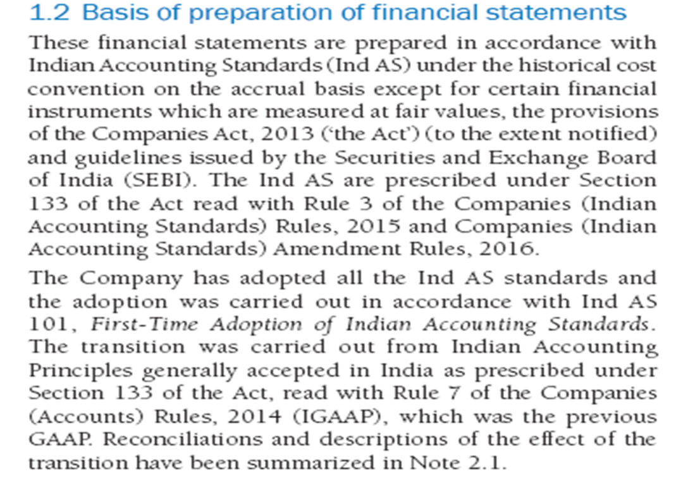

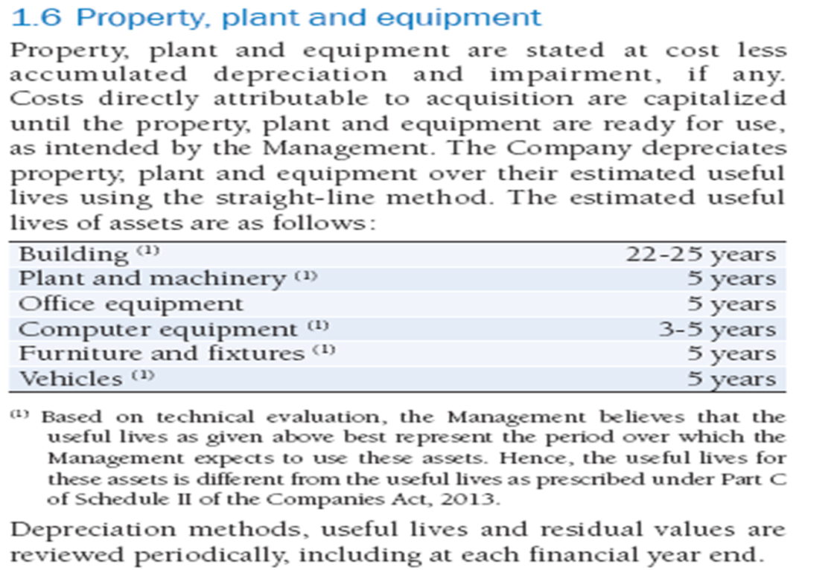

**Auditing Standards**

Mandatory u/s 143 (9)

Total compliance to be ensured

A cultural change required

*SRS 4410*

**New Reporting Requirements 143 (3) (f) , (h) & Sec 197(16)**

Any qualification, reservation or adverse remark relating to the maintenance of accounts and other matters connected therewith.

Observations or comments of the auditors on financial transactions or matters which have any adverse effect on the functioning of the company..

IFC Reporting - Relaxed

- SC, T/o < 50 Cr and Borr. < 25 Cr and fully compliant.

Auditor to make a statement in his report as to whether remuneration paid by the company is in accordance with Sec 197.

Impact of Pending Litigations on Financial Position

Provision as required by AS for material foreseeable losses on

long term contracts including derivative contracts have been made.

Delay if any in transferring funds to IEPF.

**New format of Auditors Report**

Given as Appendix to :

SA 700

SA 705

SA 706

SA 701 – KAMs & Consequential changes in 700, 705 & 706

**ICDS**

* 10 Standards as on date
* Applies to Business Income/IoS.
* To be complied with while computing IT.

**In Form 3CD, from AY 17-18**

Clause 13 :-

1. Whether any adjustment is required to be made to the profit or loss for complying with the provisions of ICDSs notified u/s. 145 (2).
2. If answer to (d) above is affirmative, give details of such adjustment.

**Guiding Pronouncements of ICAI**

GN on Fraud Reporting u/s 143 (12 )

GN on reporting u/s 143 (3) (f) & (h)

AG on Depreciation

GN on CARO 2016.

IG on SA 700,705 & 706

IG on SA 701 - KAMs

**Audit Process**

* Opening Balance Checking
* IC Evaluation & Communicating Findings to TCWG
* Vouching
* Ledger Analysis
* Verification
* Analytical Review
* Comparing FS with Books – Signed TB.
* AS Compliance
* Schedule III Compliance - Info for Notes
* CARO Points –Informed Reporting

**Let us**  **…… Let us change**

* Infrastructure & Technology
* People & Processes
* Billing & Collection
* Financial Planning
* Attitude … Attire … Cut down on Social Media
* Student friendly… Academic Culture .
* A Happy Organisation