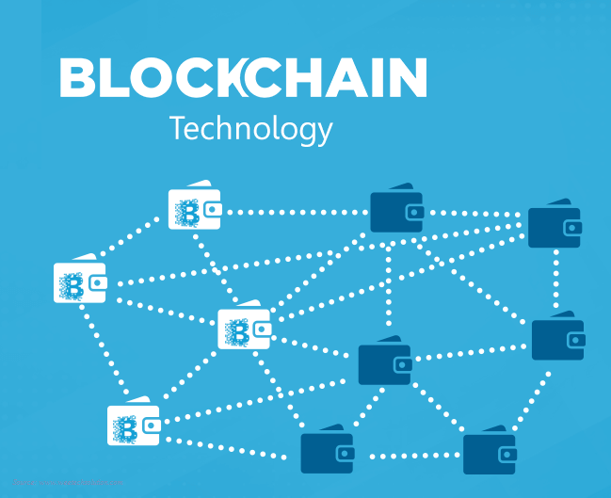
Rajendrakumar .K; FCA; LLB; CISA(USA); DISA (ICA); Dip.(Comp. Eng.)

block chain- intuition
Block chain is a disruptive technology that is set to change the landscape of computing in this decade or next. This technology has its origin in the 1980s with the search for a solution for time stamping of documents. It is set to bloom fully in another decade and the technology already has its off shoot in the birth of cryptocurrencies which draw its fiat from no sovereign power on earth.
  - Block chain- freedom from chains?

block chain- intuition
  - Block chain- freedom from chains?

  - 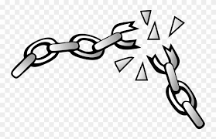

  - crypto chain for blocks of data

Sounds contradictory? - In essence yes. This disruptive technology is the culmination of the inherent human desire to break free from controlling regimes that throttle the true entrepreneurial spirit that drives the capitalist economy. We Indians have been born chained to a myriad of legislations that regulate every step of progression of a business entity form its inception to its ultimate demise- is not its demise accelerated by the control regimes?
As we traverse this journey together through the BLOCKS (the building blocks) and the CHAINS that bind them, we will be able to decipher what these terms mean and how the technology can ultimately free you from the tyranny of the shackles that impede our progress. Though the technology of block chain appears bewildering to a lay man, my endeavor shall be to walk you through this fascinating journey in to a future technology.
Client server vs. Distributed computing
Before we begin our journey, it will be worth taking a peep in to the technological evolution that fashioned the client- server computing, that is the back bone of all data processing models that we encounter now.
In the pre-PC and pre-Internet era, we had the Client Server computing, with the data and the programs lying on a server like IBM Mainframes, connected to dumb terminals. The connection between the server and the client had been secured through physical cables. In this model, both the data and the programs lay on the server and the client machines just served as consoles to input the data to the server and to receive the processed result from the server
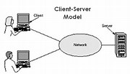
Client server model- star topology

With the advent of the PCs having processing power, partial processing of data was done at the client and the server mainly functioned as a data server, providing the client with the data requested by it. To unwrap this technology, we can draw an analogy to our Tally Server in our offices where the data lies centrally, and the Tally client lying on each of our PC does the processing of the data.
The birth of the internet revolutionized the way data was transmitted across the globe and this expanded the client server computing model to encompass specialized remote servers like Data servers, File Servers, Mail servers , Data Base servers and a host of other services. In these paradigms, the servers merely act as machines for storing and delivering the data needed by the client machines. This also marks a phase where we are freed from the wires that entangled us.
In all these models, the data was centralized in the server and security of data faced a major threat. Theoretically, there was no assurance of the security or secrecy of the data, more so in the case of sensitive data like data of banks etc. This centralized data storage also favored control regimes so that it is easier for them to implement regulations and ensure compliance.
The Block Chain Technology is a distributed frame work or otherwise known as peer- to- peer(P2P) network where there is no centralized server storing the data. Each computer, called a node, is a peer to other computers in the network and each computer has all the data of the Data Base, stored in it. You may notice that each node is connected to ever other node. Sounds like freedom from the central control? We will explore this more together, in the in the coming discussions.
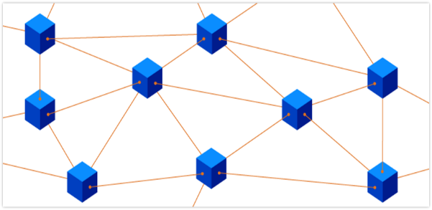
P2P network- mesh topology
If I have been able to whet your curiosity, stay glued for more!

